Steps to follow:
1.Navigate to this URL https://kiro.dev/downloads/
2. Scroll down to locate the “Latest IDE” section. Click the Download button and choose the appropriate version based on your operating system (macOS or Windows).

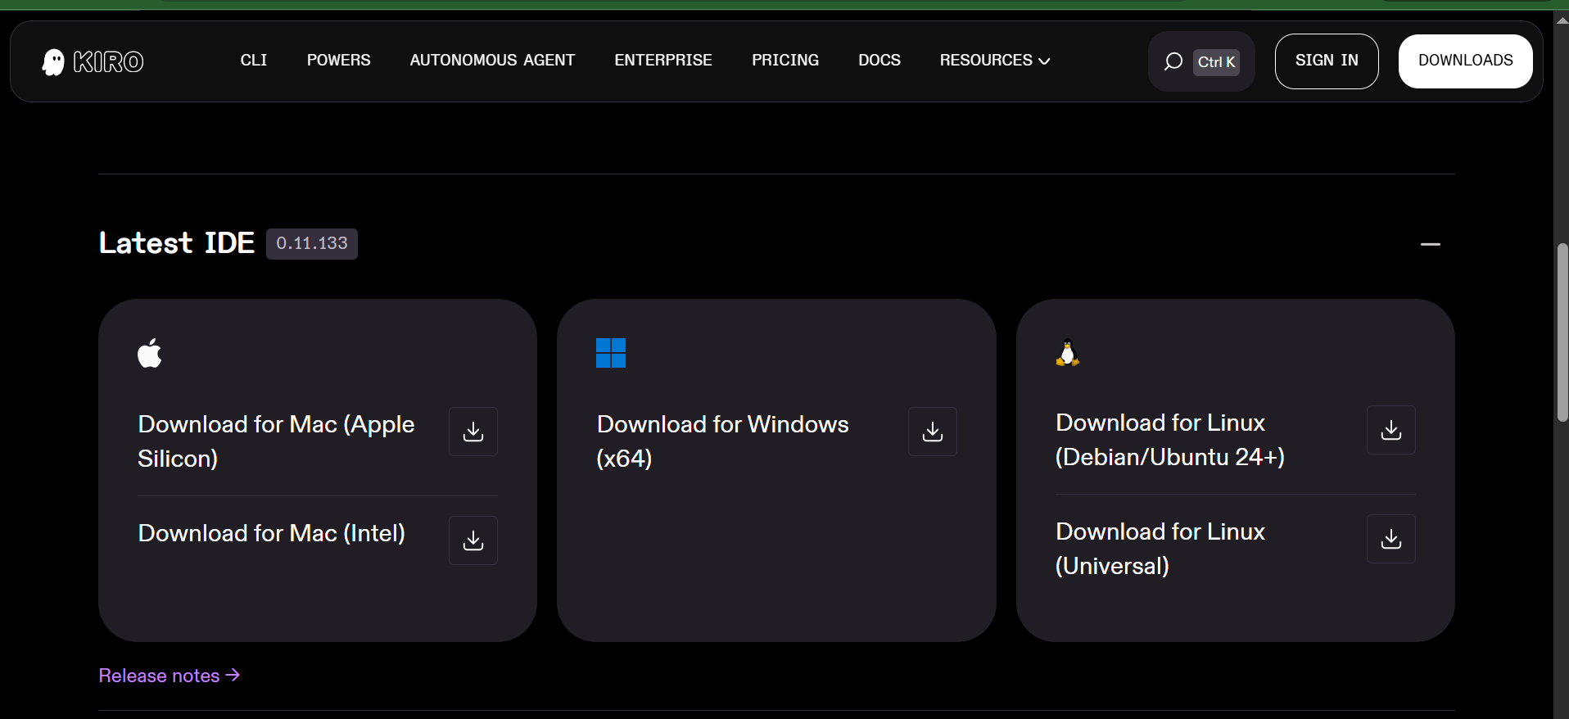
3.
• Locate the downloaded .exe file
• Double-click to launch the installer
• Click Next on the setup wizard
• Accept the license agreement
• Choose installation location (or keep default)
• Click Install
• Wait for installation to complete
• Click Finish

4. First-Time Setup
- Open Kiro IDE
- Sign in (if required) with google or github etc..

